A Novel STATCOM Based on Diode-Clamped Modular Multilevel Converters
ABSTRACT
A new static synchronous compensator (STATCOM) based on the diode-clamped modular multilevel converter (DCM2C) is proposed in this paper. In this converter topology, the capacitor voltage is clamped by using a low power rating diode in each submodule. The quantity of voltage sensors is significantly reduced and is free from the number of voltage levels. Furthermore, the voltage balancing control method becomes very simple and the capacitor voltage balance speed is fast. Based on the structure of modular multilevel converter, the DCM2C-STATCOM has the capability of Var compensation and negative-sequence current compensation. The topology characteristics and compensation control method of DCM2C-STATCOM are investigated in this paper. Experimental results obtained from a laboratory prototype validate that the capacitor voltage of the proposed DCM2C-STATCOM can be well balanced and the Var and negative-sequence current compensations are effective.

BLOCK DIAGRAM FOR PROPOSED SYSTEM
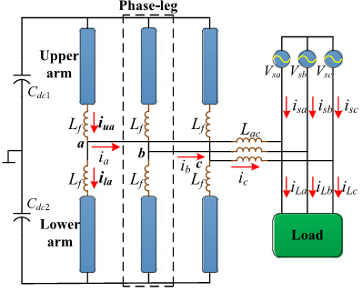
Fig. 1. MMC-STATCOM circuit configuration.
DESIGNG SOFTWARE AND TOOLS:
MAT LAB /SIMULATION Software and simu power systems tools are used. Mainly control system tools, power electronics and electrical elements tools are used.

